AGRICISION: A Machine Learning Based Crop Yield Prediction System

Aystages Njovana, Wellington Manjoro

Department of Software Engineering, School of Information Sciences and
Technology Harare Institute of Technology, Harare, Zimbabwe

stagienjovana@gmail.com ; wmanjoro@hit.ac.zw

Abstract
The agricultural sector plays a pivotal role in ensuring food security and sustaining livelihoods worldwide. Crop yield prediction is a fundamental aspect of agricultural planning and decision-making processes. Traditional methods of yield estimation often lack accuracy and fail to capture the dynamic nature of environmental factors influencing crop growth. In response, this software employs machine learning algorithms to predict crop yields with improved precision and reliability. By leveraging historical data, weather patterns and other relevant parameters, this software facilitates informed decision-making for farmers, agronomists, and policymakers. This paper outlines the development and implementation of my crop yield prediction software, highlighting its potential to revolutionize agricultural practices and enhance productivity.

INTRODUCTION
In an era marked by population growth, climate variability, and evolving agricultural practices, ensuring global food security has emerged as a paramount challenge. At the heart of this challenge lies the ability to predict and optimize crop yields with precision and reliability. Traditional methods of yield estimation often fall short in capturing the complex interplay of environmental factors that influence crop growth, leading to suboptimal decision-making for farmers and policymakers alike.

To address this pressing need, my project endeavors to harness the power of machine learning to revolutionize crop yield prediction. By leveraging historical data, real-time weather information, soil characteristics, and agronomic practices, our software aims to provide accurate and actionable insights into future crop yields. Through the integration of advanced algorithms and predictive modeling techniques, we seek to empower agricultural stakeholders with a tool that not only forecasts yields but also identifies optimal strategies for enhancing productivity and resilience in the face of changing climatic conditions.

The implications of our project extend far beyond the realm of agriculture. By equipping farmers, agronomists, and policymakers with the tools they need to make informed decisions, we aspire to catalyze sustainable development, alleviate food insecurity, and promote resilience in agricultural systems worldwide. This introduction sets the stage for our exploration of crop yield prediction through the lens of machine learning, underscoring the transformative potential of technology in shaping the future of agriculture.

PROBLEM STATEMENT
The agricultural sector faces challenges in accurately predicting crop yields due to complex interactions between environmental factors, crop management practices, and natural variability. Traditional methods of yield estimation often lack precision and scalability, leading to suboptimal decision-making and resource allocation in farming operations. There is a critical need for an advanced crop yield prediction software solution that leverages machine learning techniques to enhance predictive accuracy, support data-driven decision-making, and optimize agricultural productivity. The variability of environmental factors such as weather patterns, soil conditions, and pest/disease outbreaks complicates accurate yield estimation using conventional methods and also traditional approaches to yield prediction struggle to scale with increasing data volumes and geographic diversity, hindering their effectiveness in diverse farming contexts.The successful development and implementation of a crop yield prediction software using machine learning techniques will enable stakeholders in the agricultural sector to make informed decisions, improve productivity, and promote sustainable farming practices. By harnessing the power of data analytics and predictive modeling, the software aims to revolutionize crop yield estimation and support the transition towards data-driven agriculture.

RELATED WORK
Recent research in crop yield prediction has focused on leveraging machine learning algorithms to analyze diverse datasets and extract meaningful insights into crop growth dynamics. Lobell et al. (2009) applied support vector regression (SVR) to predict maize yields using weather and satellite-derived vegetation indices, achieving high accuracy compared to traditional statistical methods. Similarly, Wardlow and Egbert (2016) demonstrated the efficacy of random forest regression in forecasting soybean yields based on multi-temporal satellite imagery and meteorological data. Ensemble learning techniques, such as gradient boosting machines (GBM), have also shown promise in improving prediction accuracy by combining multiple models and feature sets (Wu et al., 2020).

In addition to machine learning algorithms, researchers have explored the integration of diverse data sources to enhance crop yield prediction models. Sakamoto et al. (2018) integrated satellite imagery, weather data, and soil moisture information to forecast rice yields with high spatial resolution, enabling precision agriculture practices. Gebremichael et al. (2020) utilized remote sensing data to detect crop stress and predict sorghum yields under varying water availability conditions. Furthermore, Muller et al. (2019) emphasized the importance of incorporating socio-economic factors, such as market prices and policy interventions, into yield prediction models to improve their relevance and applicability in real-world decision-making contexts.These studies collectively highlight the diversity of approaches and methodologies used in crop yield prediction, ranging from traditional regression techniques to advanced machine learning algorithms. They underscore the importance of leveraging multi-source data, including satellite imagery, weather observations, soil characteristics, and socio-economic factors, to develop accurate and actionable yield forecasts that support sustainable agricultural practices and food security initiatives. By building upon the insights and findings of previous research, this system aims to contribute to the advancement of crop yield prediction systems, leveraging state-of-the-art machine learning techniques and domain-specific knowledge to address challenges and opportunities in agricultural decision-making.

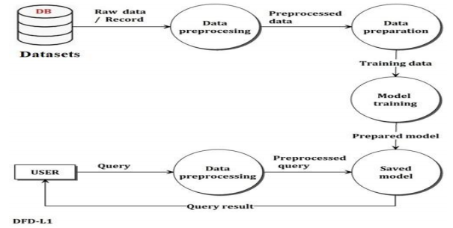
Figure 1 DFD of existing system

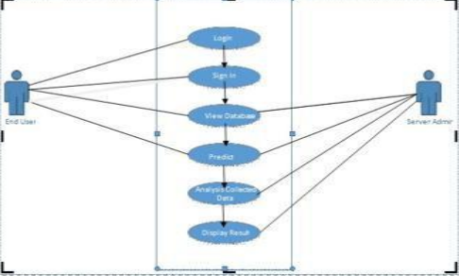
Figure 2 Use Case Diagram for existing system

SOLUTION
To eradicate the problems of the current crop yield prediction software, I aim develop a ensemble algorithm machine learning based crop yield prediction software which is based on mainly weather inputs and other data with the following objectives:
- To predict crop yield using Area(e.g Zimbabwe), Item(e.g Wheat), Year, average_rain_fall_mm_per_year,pesticides_tonnes and avg_temp
- To suggest the best crop to plant according to the parameters provided
- To generate prediction reports for future cross referencing

Features of the system
1. Multi-Source Data Integration: The Crop Yield Prediction System integrates diverse data sources, including historical yield records, weather data, soil health indicators, and satellite imagery. This multi-source data integration enables comprehensive analysis and modeling of crop growth dynamics.

2. Machine Learning Algorithms: Utilizing advanced machine learning algorithms such as Random Forest Regression, Gradient Boosting Machines (GBM), or deep learning architectures, the system develops predictive models that capture complex relationships between environmental factors and crop yields.

3. Actionable Insights and Recommendations: It generates actionable insights and recommendations for farmers and agronomists, guiding them on optimal planting schedules, irrigation strategies, and crop management practices to maximize yields and profitability.

Benefits of the system
Improved Crop Planning: The system enables informed crop planning and management strategies based on accurate yield forecasts, reducing uncertainty and optimizing resource allocation.

Enhanced Productivity: By leveraging predictive analytics, the system enhances productivity and profitability for farmers, promoting economic sustainability and food security.

Sustainable Agriculture: It supports sustainable agricultural practices by promoting efficient resource use, reducing waste, and mitigating environmental risks associated with crop production.

Solution Architecture
The client-side of the web app is implemented using HTML, CSS, and JavaScript. The user interacts with the client-side of the web app using a web browser. The client-side of the web app interacts with the server-side of the web app using HTTP requests.The server-side of the web app is responsible for interacting with the system database.It is implemented using Python flask as the backend.
The web app uses the following architecture:
1. User Interface Layer: The user interface layer is the
client-side of the web app. It consists of HTML,
CSS, and JavaScript. The user interacts with the
web app using a web browser. The user interface
layer sends HTTP requests to the server-side of the
web app.
2. Application Layer: The application layer is the
server-side of the web app. It consists of a web
server containing a MySQL database. The web server
receives HTTP requests from the user interface
layer and processes them.
3. Data Layer: The data layer consists of the data
stored in the MySQL database.

RESULTS AND FUTURE WORK
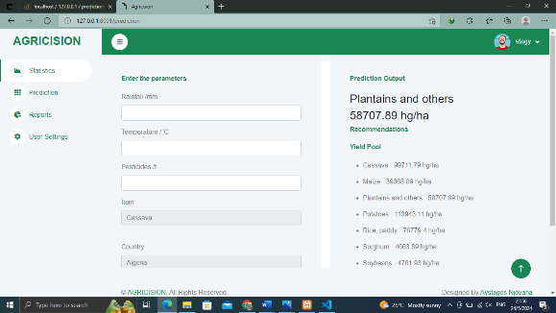
Figure 5: The interface for prediction processing

The system performed well in predicting crop yields and recommending which crop to plant based on the user input and calculating yield for each crop and taking the highest value . The results achieved are summarized in Table 1.

Objective | Fully Achieved | Partially Achieved
To predict crop yield using Area(e.g Zimbabwe), Item(e.g Wheat), Year, average_rain_fall_mm_per_year,pesticides_tonnes and avg_temp

To suggest the best crop to plant according to the parameters provided

To generate prediction reports for future cross referencing

Future works
The development of the Crop Yield Prediction System opens up several avenues for future enhancements, research, and implementation to further advance the capabilities and impact of agricultural decision support tools.

1. Integration of Additional Data Sources
Explore the integration of additional data sources, such as remote sensing technologies (e.g., hyperspectral imaging, drones), IoT devices (e.g., soil sensors, weather stations), and socio-economic indicators (e.g., market prices, policy interventions), to enrich predictive models and capture broader contextual insights.

2. Enhancement of Machine Learning Algorithms
Investigate advanced machine learning techniques, including deep learning architectures (e.g., convolutional neural networks, recurrent neural networks) and ensemble methods (e.g., stacking, model blending), to further improve predictive accuracy, interpretability, and robustness across diverse crops and geographical regions.

3. Real-time Monitoring and Adaptive Recommendations
Implement real-time monitoring capabilities and adaptive decision support systems that dynamically adjust recommendations based on evolving environmental conditions, market trends, and user preferences. Explore the use of reinforcement learning and adaptive control strategies to optimize resource allocation and maximize crop yields.

4. User Interface and Visualization Tools
Enhance the user interface (UI) and visualization tools to provide interactive dashboards, customizable reports, and intuitive data exploration features. Incorporate geographic information systems (GIS) and spatial analytics to visualize crop performance and environmental factors at different scales.

5. Collaboration and Knowledge Sharing Platforms
Develop collaborative platforms and knowledge sharing networks that enable farmers, researchers, and policymakers to exchange insights, best practices, and validated data for informed decision-making and collective learning in agriculture.

CONCLUSION
In conclusion, the development and implementation of the Crop Yield Prediction System represent a significant advancement in leveraging machine learning and data analytics to address challenges in agricultural productivity and sustainability. Through the integration of diverse data sources, advanced modeling techniques, and user-friendly interfaces, the system offers actionable insights and decision support tools for farmers, agronomists, and policymakers.

Key Achievements:

- Predictive Accuracy: The system has demonstrated improved predictive accuracy in forecasting crop yields based on environmental variables, historical trends, and agronomic practices. This capability empowers stakeholders to make informed decisions regarding planting schedules, resource allocation, and risk management.
- Usability and Accessibility: The user-friendly interface and visualization tools enhance usability and accessibility, enabling stakeholders with varying levels of technical expertise to interact with the system and interpret results effectively.
- Scalability and Adaptability: The system's scalability and adaptability facilitate its deployment across diverse agricultural settings, accommodating varying data volumes, crop types, and geographic regions.

Impact and Implications:

- The adoption of the Crop Yield Prediction System has the potential to transform agricultural decision-making, promoting data-driven practices, optimizing resource use, and enhancing sustainability in farming operations.
- By providing timely and accurate yield forecasts, the system supports resilience against climate variability, economic uncertainties, and market fluctuations, enabling farmers to mitigate risks and maximize productivity.
- The project underscores the importance of interdisciplinary collaboration, leveraging technology, and harnessing data-driven approaches to address complex challenges in modern agriculture.

Future Directions:

- As we look ahead, future efforts will focus on advancing predictive modeling techniques, integrating additional data sources, and exploring real-time monitoring capabilities to further enhance the system's performance and usability.
- Collaborative initiatives with stakeholders, researchers, and policymakers will be essential to validate the system's effectiveness, promote knowledge sharing, and foster innovation in sustainable agriculture.

In summary, the Crop Yield Prediction System represents a promising tool for optimizing agricultural practices, enhancing productivity, and promoting resilience in the face of evolving environmental and economic conditions. This project underscores our commitment to leveraging technology for positive impact in agriculture and fostering sustainable food production for future generations.

REFERENCES

”Computers and Electronics in Agriculture”,Vol 177, October 2020, 105709,Crop yield prediction using machine learning: A systematic literature review,Thomas vanKlompenburg , Ayalew Kassahun , Cagatay Catal
2. ”Advances in Agronomy”,Vol 154, 2019, Pages 201-255,Chapter Four - Seasonal crop yield forecast: Methods, applications, and accuracies Bruno Basso a, Lin Liu

- R. Medar, V. S. Rajpurohit and S. Shweta, "Crop Yield Prediction using Machine Learning Techniques," 2019 IEEE 5th International Conference for Convergence in Technology (I2CT), Bombay, India, 2019, pp. 1-5, doi: 10.1109/I2CT45611.2019.9033611.

- S Iniyan, V Akhil Varma, Ch Teja Naidu,
Crop yield prediction using machine learning techniques,Advances in Engineering Software,
Volume 175,2023,103326,ISSN 0965-9978,
https://doi.org/10.1016/j.advengsoft.2022.103326.
(https://www.sciencedirect.com/science/article/pii/S0965997822002277)

- Elbasi, E.; Zaki, C.; Topcu, A.E.; Abdelbaki, W.; Zreikat, A.I.; Cina, E.; Shdefat, A.; Saker, L. Crop Prediction Model Using Machine Learning Algorithms. Appl. Sci. 2023, 13, 9288. https://doi.org/10.3390/app13169288

- E.J. Reddy and M. R. Kumar, "Crop Yield Prediction using Machine Learning Algorithm," 2021 5th International Conference on Intelligent Computing and Control Systems (ICICCS), Madurai, India, 2021, pp.1466-1470,doi: 10.1109/ICICCS51141.2021.9432236.

- Sailaja, M. & Kumari, Gaddala & Pinninti, Monika & Rupaswi, Mandava & Reddy, Kallam & Kodeboyina, Uday & Kodepogu, Koteswara Rao & Surekha, Yalamanchili. (2023). Crop Yield Prediction Based on Machine Learning Techniques. 1335-1341. 10.1109/ICCPCT58313.2023.10245132.
8. Ed-Daoudi, R., Alaoui, A., Ettaki, B., and Zerouaoui, J. (2023). Improving Crop Yield Predictions in Morocco Using Machine Learning Algorithms. Journal of Ecological Engineering, 24(6), pp.392-400. https://doi.org/10.12911/22998993/162769

9.P.Priya, U.Muthaiah2 and M.Balamurugan3. “PREDICTING YIELD OF THE CROP USING MACHINE LEARNING ALGORITHM.” (2018).

10.Kavita Jhajharia, Pratistha Mathur, Sanchit Jain, and Sukriti Nijhawan. 2023. Crop Yield Prediction using Machine Learning and Deep Learning Techniques. Procedia Comput. Sci. 218, C (2023), 406–417. https://doi.org/10.1016/j.procs.2023.01.023

